**Class Work Monday, January 20, 2025**

**Topic:**

**How search engine works**

**Written work:**

1. What is a web crawler?
2. What is search indexing?
3. 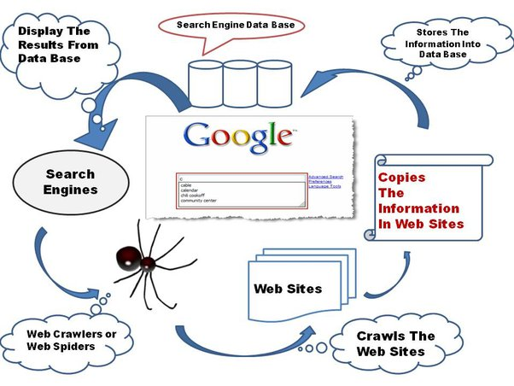Draw a diagram of how search engine works?

**Home Work**

**Q. A search engine uses an algorithm to choose websites to answer a web search question. What is an algorithm? Search the web for more information.**

**Q. Do Activity of Page#23 on notebook. Write keywords, you used in web search.**